TUGAS PRAKTIKUM 2 PEMEROGRAMAN 1

C:\Users\FAZRIL~1\AppData\Local\Temp\ksohtml\wps_clip_image-4242.png

NAMA : FAZRI RAMADHAN

NIM : 4513210018

PRAKTIKUM 2 PEMEROGRAMAN 1

**BARIS BARU**

**SOURCECODE**

|  |
| --- |
| public class barisbaru {  public static void main(String[]args) {  System.out.println ("Nama \n Saya \n Fazri");  }  } |

**PRINTSCREEN**

**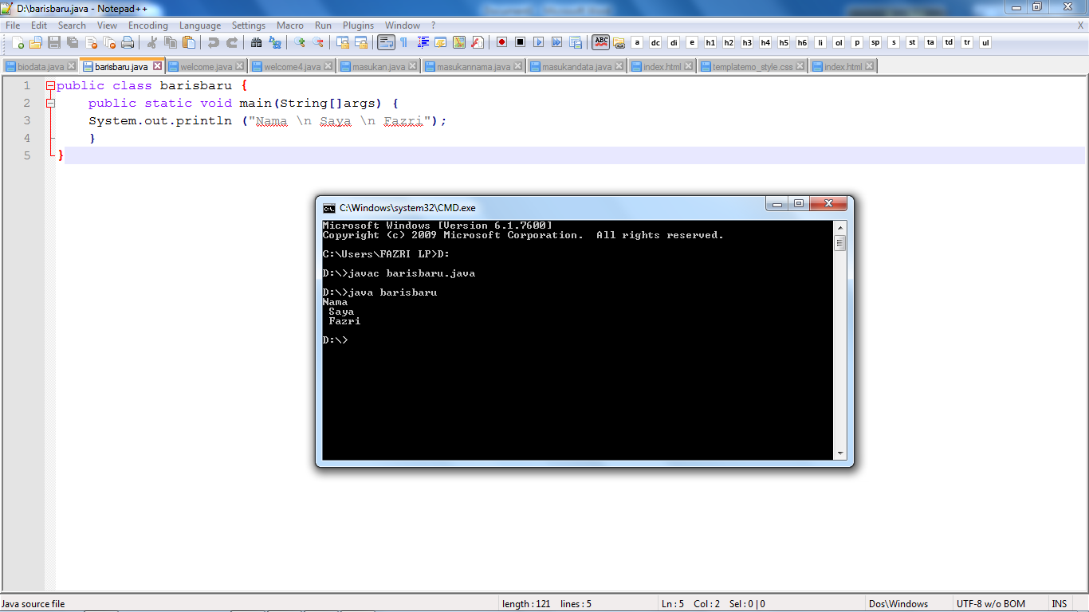**

**WELCOME**

**SOURCECODE**

|  |
| --- |
| public class welcome{  public static void main(String[]args) {  System.out.printf ("%S \n %S","welcome","java");  }  } |

**PRINTSCREEN**

**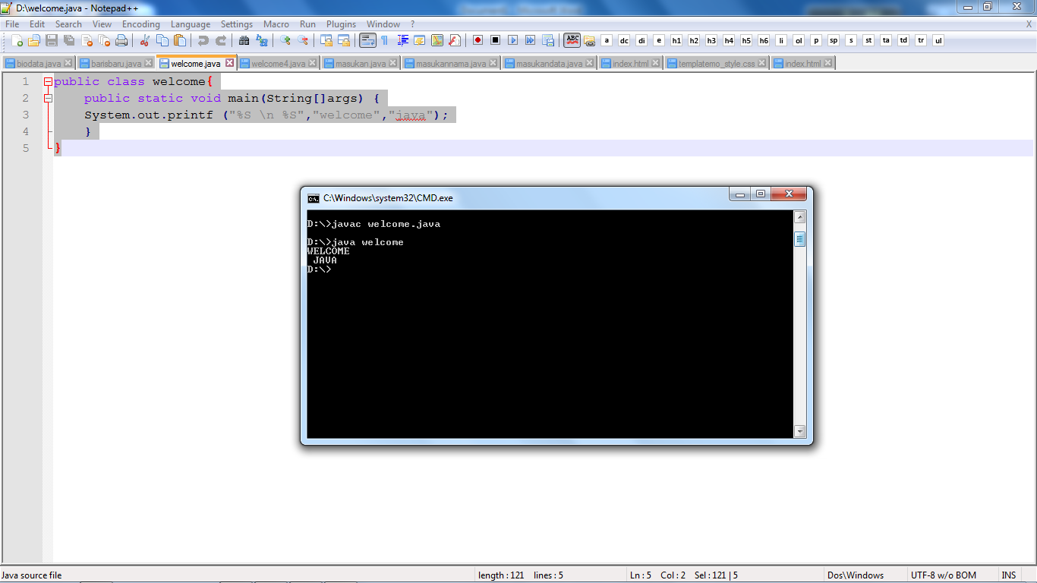**

**WELCOME 4**

**SOURCECODE**

|  |
| --- |
| public class welcome4{  public static void main(String[]args) {  System.out.printf ("%S %S %S","welcome","to","java");  }  } |

**PRINTSCREEN**

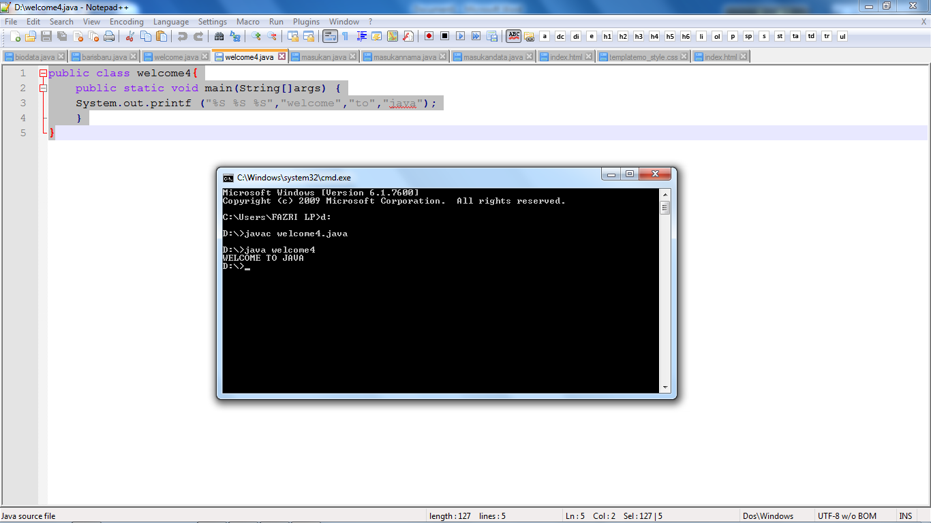

**ANGKA**

**SOURCECODE**

|  |
| --- |
| import java.util.Scanner;  public class masukan {  public static void main(String[]args){  int angkapertama;  int angkakedua;  Scanner masuk = new Scanner(System.in);  System.out.println ("masukkan angka pertama =");  angkapertama = masuk.nextInt();  System.out.println ("masukkan angka kedua =");  angkakedua = masuk.nextInt();  System.out.println (angkapertama);  System.out.println (angkakedua);  }  } |

**PRINTSCREEN**

**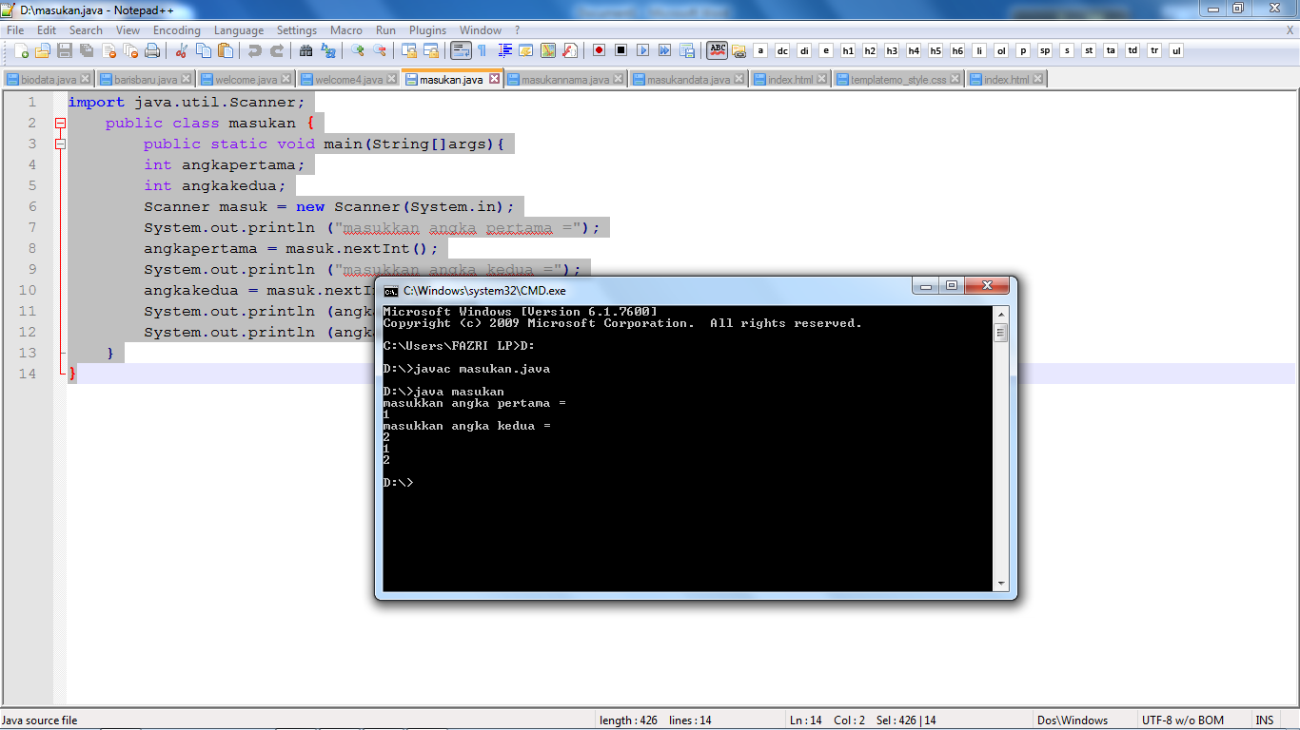**

**MASUKANNAMA**

**SOURCECODE**

|  |
| --- |
| import java.util.Scanner;  public class masukannama {  public static void main(String[]args){  String namapertama;  String namakedua;  String Npmpertama;  String Npmkedua;  Scanner masuk = new Scanner(System.in);  System.out.println ("masukkan nama pertama =");  namapertama = masuk.nextLine();  System.out.println ("masukan Npm pertama =");  Npmpertama = masuk.nextLine();  System.out.println ("masukkan nama kedua =");  namakedua = masuk.nextLine();  System.out.println ("masukan Npm kedua =");  Npmkedua = masuk.nextLine();  System.out.println (namapertama);  System.out.println (namakedua);  System.out.println (Npmpertama);  System.out.println (Npmkedua);  }  } |

**PRINTSCREEN**

**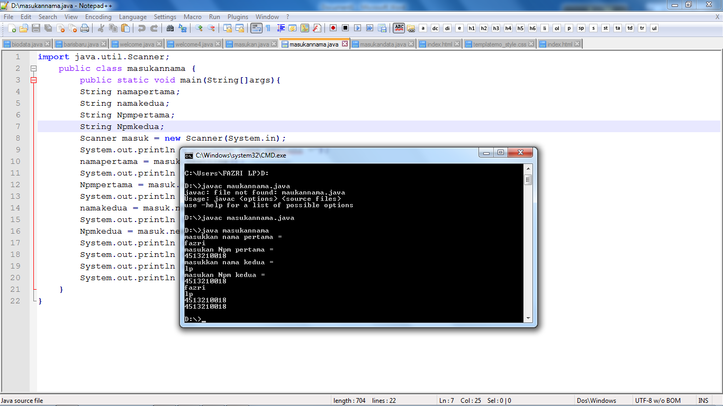**

**MASUKANNAMA**

**SOURCECODE**

|  |
| --- |
| import java.util.Scanner;  public class masukandata {  public static void main(String[]args){  String nama;  String Npm;  int nilaitugas1;  int nilaitugas2;  float nilairatarata;  float nilairata;  Scanner masuk = new Scanner(System.in);  System.out.println ("masukkan nama =");  nama = masuk.nextLine();  System.out.println ("masukan Npm =");  Npm = masuk.nextLine();  System.out.println ("masukan nilai tugas1 =");  nilaitugas1 = masuk.nextInt();  System.out.println ("masukan nilai tugas2 =");  nilaitugas2 = masuk.nextInt();  System.out.println ("masukan nilai rata-rata =");  nilairata = nilaitugas1 + nilaitugas2;  nilairatarata = nilairata/2;  System.out.println (nama);  System.out.println (Npm);  System.out.println (nilairatarata);  }  } |

**PRINTSCREEN**

**